System parameters identification Scilab/Xcos

This tutorial displays a typical use case of optimization of control systems. The identification of parameters for a controller usually proceeds in the following steps:

1. Data acquisition of the system to regulate in open loop
2. Modeling the dynamic system
3. Identification of the system parameters
4. Set up of a control strategy (simple PID, to more evolve Model Predictive Control)

*Example* :

Second order system

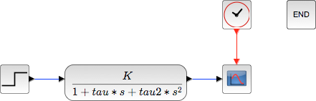

Running a simulation with a unit step input (with the parameters K, Tau et Tau2 all equals 1):

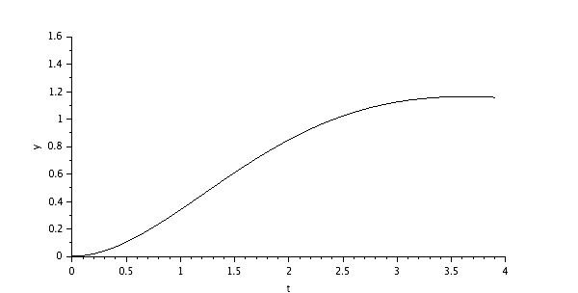

Introduction of the block “to workspace” to gather the results of the simulation in the Scilab environment for post-processing:

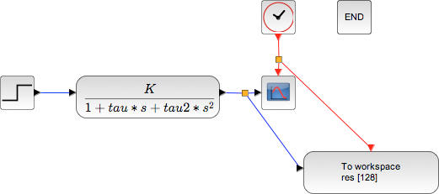

Those results are then accessible through the variable *res*, contening 2 fields :

* values
* time

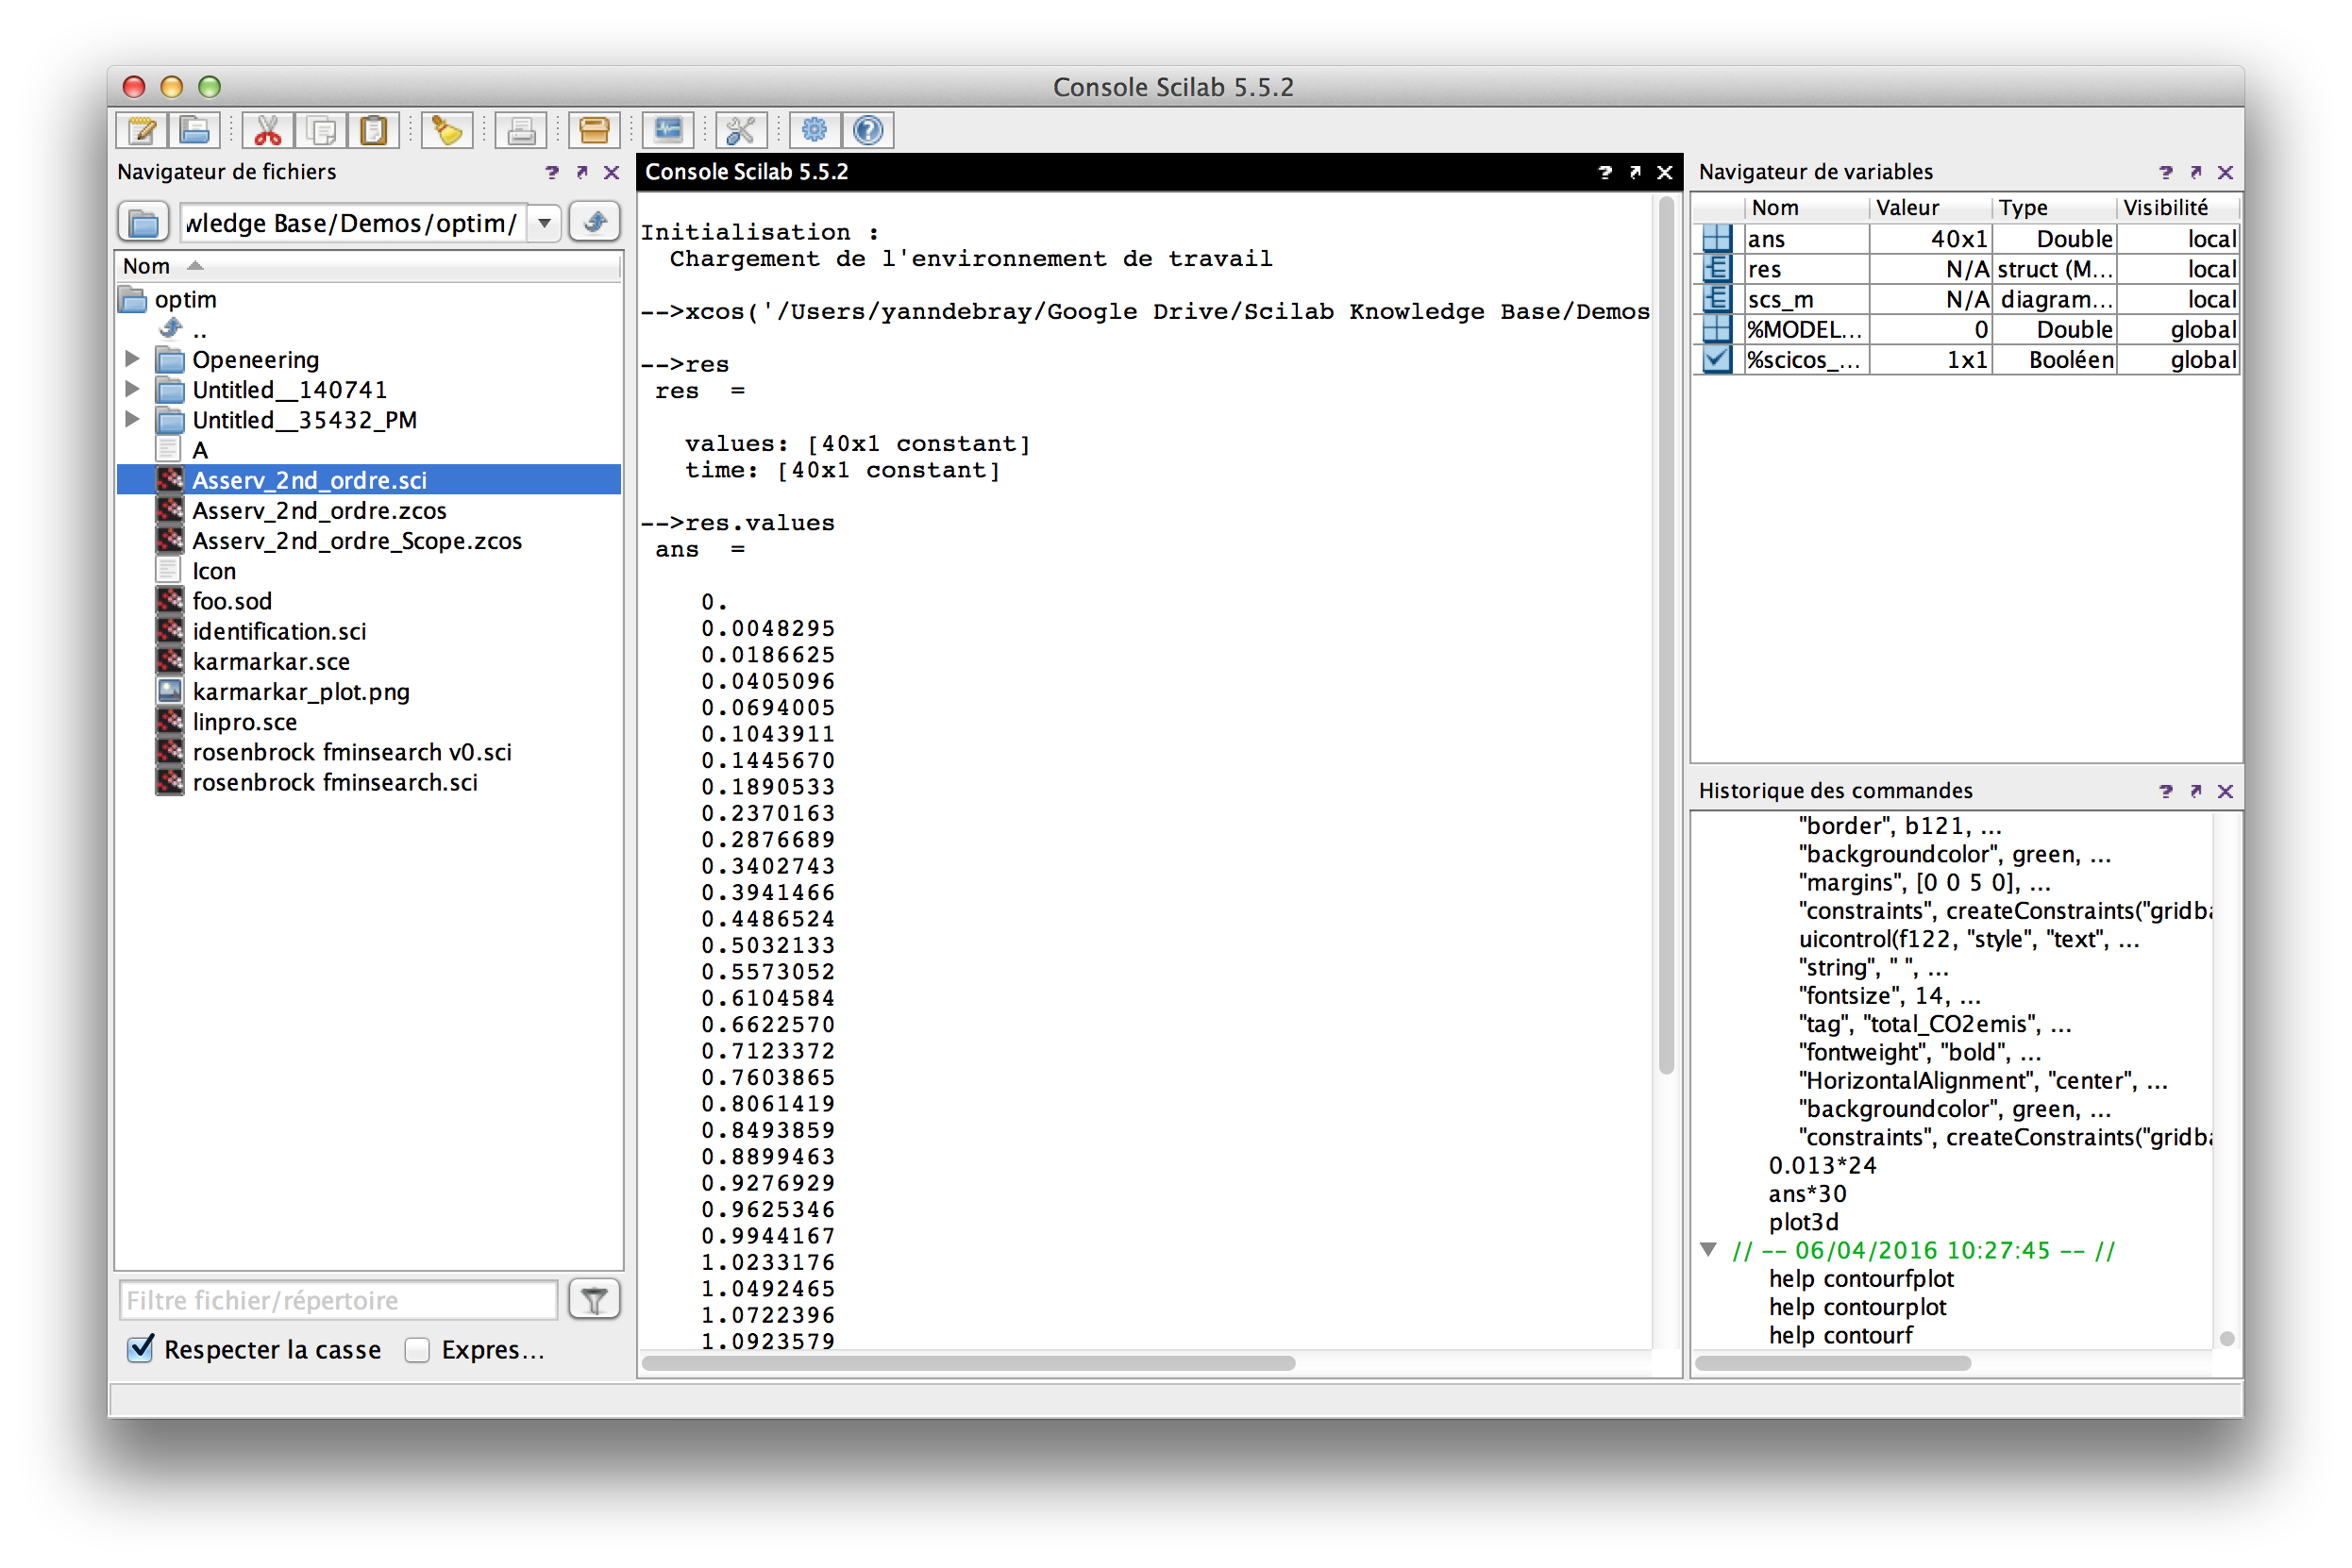

Next step: Write an optimization script running Xcos in batch to identify the 3 parameters of the second order system (K, Tau and Tau2).

Defining a cost function returning y, the distance between the simulated curve of the system and the unit step input function.

function **y**=cost_for_fminsearch(**x**)  
 context = ["K="+string(**x**(1)) "tau="+string(**x**(2)) "tau2="+string(**x**(3))];  
  
 *// On impose un cout infini si on sort de nos bornes de recherche.*  
 if **x**(1) < 0 | **x**(2) < 0 | **x**(3) < 0 then  
 **y**=%inf  
 return  
 end  
  
 try  
 *// Ouverture du diagramme => cree une variable scs_m*  
 importXcosDiagram(pwd()+"/Asserv_2nd_ordre.zcos");  
 *// Changement du contexte*  
 scs_m.props.context = context;  
 *// Simulation*  
 xcos_simulate(scs_m, 4);  
 catch  
 disp("Error during xcos Simulation ...");  
 error("cost function failed.")  
 **y** = %inf;  
 return  
 end  
  
 res_ref = ones(40,1);  
 **y** = norm(res.values - res_ref)^2;  
 e = get("costPolyline");  
   
 e.data(:, 2) = res.values;  
endfunction

The results are represented dynamically from this script iterating until finding the optimal solution in the defined interval:

f = gcf();  
plot([0, 3.9], [1, 1], "r");  
plot([0:0.1:3.9], zeros(40, 1));  
e = gce();  
e.children(1).tag = "costPolyline";  
a = gca();  
a.data_bounds = [0, 0 ; 4, 1.8]

The optimization function called to identify the 3 systems parameters is [fminsearch](https://help.scilab.org/docs/6.0.2/en_US/fminsearch.html) :

opt = optimset( "Display" , "iter" );  
[x fval] = fminsearch ( cost_for_fminsearch , [0 0 0] , opt );

The calling syntax of this function is:

* Cost function defining the quantity to minimize:   
  cost_for_fminsearch
* Starting point of the search:  
  [0 0 0]
* Advanced options with the function [optimset](https://help.scilab.org/docs/6.0.2/en_US/optimset.html):   
  options.Display = "iter" → the algorithm returns a message at each iteration

You can develop a Graphical User Interface (GUI) to modify manually the 3 parameters or trigger the automatic identification. When deployed on the Cloud, this application provides the interface on the right:

